Modeling Stock Market Data (R)
Finviz-style snapshot → clean numerics → outlier EDA → 10-flag relative value → screen → 50/200-day MAs
Problem Statement
A cross-section of listed names arrives as a messy CSV (%, $, commas). The analyst must decide which names look cheap versus their sector and industry neighbors, then inspect the price path of a short list — without treating a mean warped by one Class-A share as “the market.” Live Finviz and 2014 Yahoo ichart URLs from the book no longer make a reproducible lab.
Solution Strategy
- Bundle data/finviz.csv (1,101 names) and data/historical_prices.csv; keep the book export URL as a comment.
- clean_numeric via gsub; apply to every field after the six identifiers.
- Histogram raw vs Price<150; sector bars; drill Financial → P&C → BRK-A ($172,450); drop it and re-average.
- melt → mean → dcast sector and industry Price/PE/PEG/PS/PB; ten below-average flags; RelValIndex 0–10.
- Hard screen (USA, $20–100, volume, +EPS, D/E<1, β<1.5, inst<30, index≥8) + zoo rollmean overlays.
Solution
Financial-sector mean price is ~$665 with BRK-A and falls into the same $25–55 band as other sectors once the Class-A share is removed. Most names cluster under $50 after capping the histogram. RelValIndex is a teaching count, not a factor model; raising the cutoff from 6 to 10 shrinks the passer list sharply (see sweep chart). Bundled histories cover eight chemical / materials names with 50- and 200-day MAs.
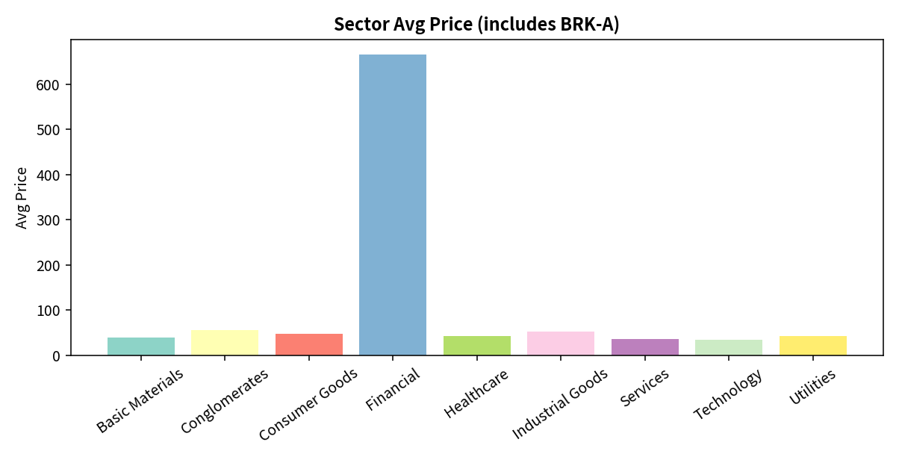
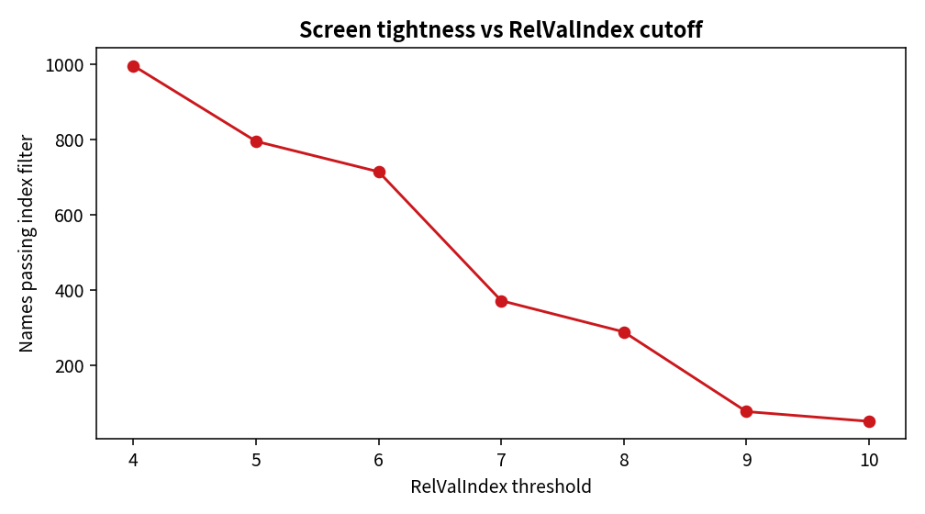
Key Takeaways
- Code the download after the first click-export; vendor URLs rot.
- Means without an outlier check lie. Always plot the raw histogram.
- Relative value compares neighbors; it is not a DCF and RelValIndex≥8 is not alpha.
- Screens exist to shrink the list. MAs describe path and volatility of survivors.
- Rewrite the same finding for quant, screener operator, CIO, and retail reader.

